Press Release, 28 th of may 2020
UFC Champion Lyoto Machida from Los Angeles heute 60 Minuten Live
UFC Legend and Karatefighter Lyoto Machida teaches first time worldwide live on live auf Facebook.
In the tough Sport Mixed Martial Arts (MMA) nobody really recognized Karate.
Until Lyoto Machida came and changed everything.
Lyoto Machida was born in Salvador, Brazil, as the third son of the highly ranked head of the Brazilian branch of the Japan Karate Association, Shotokan karate master Yoshizo Machida (町田嘉三).
Lyoto began training in karate at the age of 3 and earned his black belt at the age of 13. He also began training in sumo at the age of 8 and Brazilian jiu-jitsu and boxing at sixteen. He won a number of amateur karate tournaments, including the 2001 Pan American Karate tournament. Later he travelled to Thailand to study Muay Thai, to Japan to study grappling at the NJPW Dojo and finally to United States to pursue his UFC career.
He was the runner-up in the 2000 Brazilian Sumo Championships in the 115 kg division.
As an adult, he became Brazilian Karate Champion twice, and placed second in the South American Championship. He defeated American fighter and jiu-jitsu black belt Rafael Lovato Jr. at L.A. Sub X.
Mixed martial arts record of 26 wins, 11 by knock out.
2009 Lyoto Machida (the Dragon) became the 10th UFC Light Heavyweight Champion.
In addition to his sumo and karate achievements, he has a college degree in Physical Education.
His style is based mainly on tactics using Shotokan karate and Brazilian jiu-jitsu, but also integrates techniques from wrestling and sumo, which Machida says makes him "fully prepared for any situation" in the Octagon.
Machida Karate is based on a very traditional form which is very different from modern sports karate.
Lyoto Machida Sensei donates his lesson today to the community of Karate@Home and supports 12.000 Members from over 110 countries who can’t practice in their dojos in cause of the Corona Crisis.
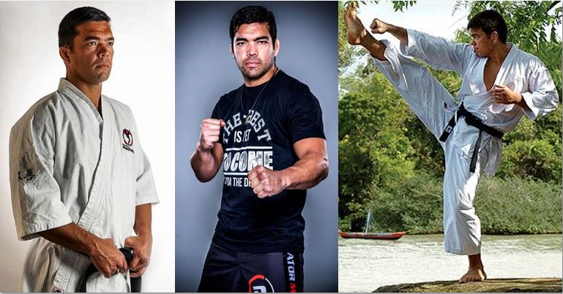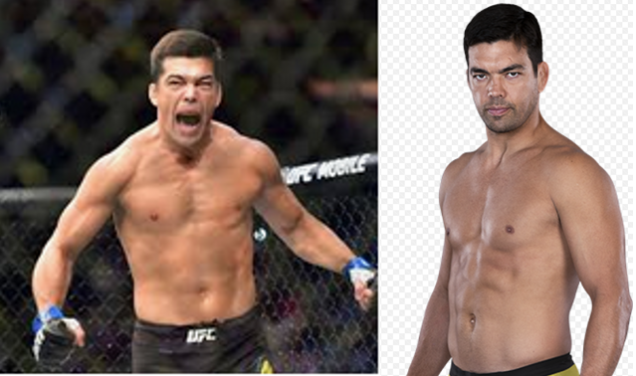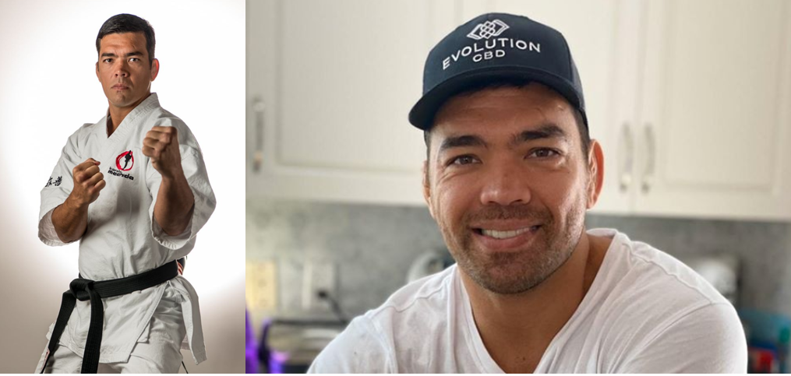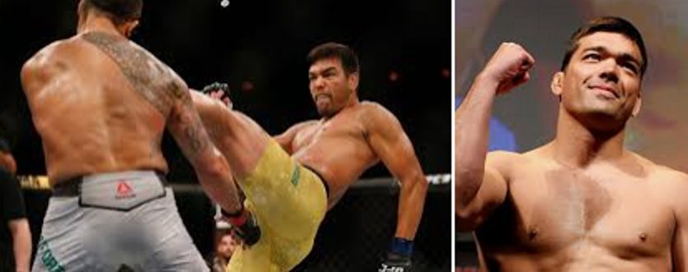

- Instagram: https://www.instagram.com/joinkarateathome
- Facebook Seite: https://www.facebook.com/KarateAtHome/?ref=bookmarks
- Facebook Gruppe: https://www.facebook.com/groups/533907517263470/
- Youtube: https://www.youtube.com/channel/UCtqGRGJtFEQiF-eHwhgRDWg/about?view_as=subscriber
- Linkedin: https://www.linkedin.com/company/karateathome/?viewAsMember=true
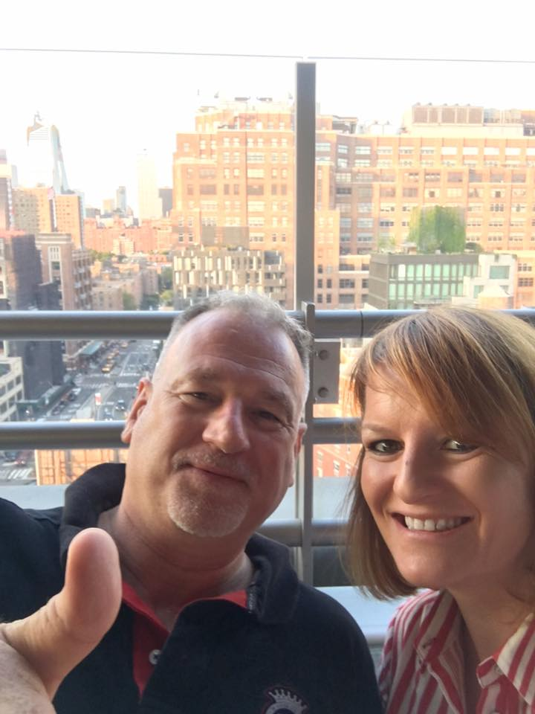
Gründer von Karate@Home:
Nadja Ines Koerner
- Trainiert seit ueber 34 Jahren und hat den 3.Dan, JKA
- Langjährige Leistungsportlerin, mehrfache Deutsche Meisterin, ehemalige Kaderathletin und Ressortleiterin PR im DJKB (Deutscher Japanischer Karate Bund)
- Langjährige Trainerin im Karate Zentrum Pforzheim
- Sensei: Hans Koerner & Hideo Ochi
- Nadja war VP Marketing bei Reckitt Benckiser in Deutschland, London und New York und zieht bald für einen neuen Job als VP mit Ihrem Mann nach Amsterdam
Martin Buchstaller
- Trainiert seit über 37Jahren und hat den 5. Dan, JKA
- Langjähriger Kaderathlet in der deutschen Nationalmannschaft, zweifacher Sieger des deutschen Shotokan Cups Kata, ehemaliger Jugendkader National Coach und ehemaliger Präsident des DJKB (Deutscher JKA Karate Bund)
- Sensei: Hideo Ochi
- Martin arbeitet als Regionalleiter Service bei Volkswagen und lebt mit seiner Frau in Köln

LOGO & IMPRESSIONS:

